14. Santhia – Vercelli
14th^{th} June

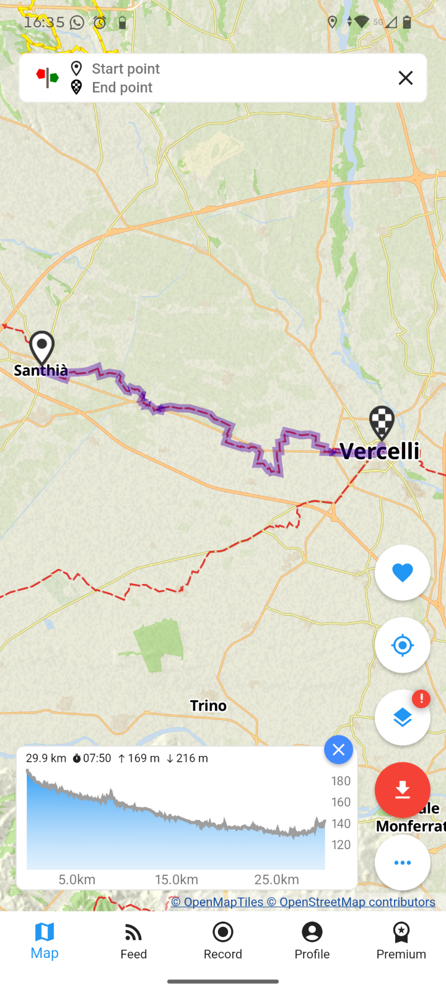
Accommodation Vercelli
Hospitale Sancti Eusebi
Address: Vicolo degli Alciati 4, 13100, Vercelli, Vercelli, Italy
Phone Numbers: +39 3342386911
Email: info@amicidellaviafrancigena.vercelli.it

